

AP Invoice approval
Functional specification Document

Cloudsuite V11 Migration

Document Information

Author(s) | Infor
Title | RICE ID – AP Invoice Approval
Version | 6.0
Customer | BAYCARE
Project | Infor CloudSuite Implementation
Phase | Build
Status | Draft In Review Approved

Contributors
Name | Role | Company
Consultant 1 | Irie Mack Pable | Infor
Developer 1 | Nikko Yabut | Infor
Business Owner | Title | BAYCARE
Functional Owner | If different form Business Owner | BAYCARE
Developer 2 | Title | BAYCARE
Reviewer 1 | Drew Greely/Viviana Wilhelm | Infor
Reviewer 2 | Title | BAYCARE
Vendor 1 | Title | VENDOR

Version Control
Version | Date | Status | Reviewer | Changes
1.0 | 9/16/2020 | Draft | David Humphrey
1.1 | 7/4/2022 | Draft | Irie Mack Pable | General update to functional specification after business requirements gathering.
1.2 | 7/12/2022 | Draft | Irie Mack Pable | Added business process flow.
1.3 | 9/16/2022 | Draft | Irie Mack Pable | Added TES-070 document object
2.0 | 10/19/2022 | Approved | Irie Mack Pable/Nikko Yabut | 2nd iteration updates and addition of technical specifications
3.0 | 11/30/2022 | Approved | Irie Mack Pable | Email notification and process narrative update for re-route due to dummy account.
4.0 | 12/22/2022 | Draft | Irie Mack Pable | Update on authority limit and exception handling when Supervisor Type is blank
4.1 | 1/5/2023 | Approved | Irie Mack Pable | Update on authority limit.
5.1 | 5/20/2024 | Approved | Irie Mack Pable | Updates in the following sections:  - Assumptions and Risks  - Email notification  - Parameters and Selection Logic  - Process Requirements  - GHR Setup
5.2 | 9/18/2024 | Approved | Irie Mack Pable | Updates related to Proxy and Relationship Status evaluation sequence. Addition of auto-reject for invoices over 30 business days in the flow.
6.0 | 08/08/2025 | Draft | Julianne Isabel Sitoy | Updates in the following sections:  - 2.5 Process Requirements  - Level 3 Approval  - APIA_NONPOROUTING_APPROVAL_MATRIX  - System Configuration

Approvals
Name | Role | Signature and Date
David Humphrey | Manager Financial Systems, BayCare Health System
Table of Contents

1.0 Functional overview 5
1.1 Functional Description and Justification 5
1.2 Assumptions and Risks 5
1.3 Dependencies 6
1.4 Functionality in Scope 7
2.1 Current Functionality 19
2.2 Parameters and Selection Logic 20
2.3 Vendor Requirements (where applicable) 22
2.4 Vendor Security 22
2.5 Process Requirements 23
2.6 Cross Reference Tables 37
2.7 Technical Details 42
2.8 Technical Data Source 47
2.9 Technical Diagram 53
2.10 Sample Pseudocode 55
2.11 Technical Deployment Notes 59
2.0 Quality assurance 60
2.1 Test Plan 60
2.2 Testing Considerations 60
3.3 Functional Testing Documentation 61
3.4 End User Training 61
3.5 Terminology 61

Functional overview
The functional specification outlines the requirements to satisfy the successful creation of the customized program (report, interface, conversion, and extension). The objective is to clearly articulate the functional, technical, application, and vendor specific details to result in the expected outcome. The remainder of the document provides context, logic, and justification for the custom program.

Functional Description and Justification
Provide a brief overview of the program objective, requirement, and business justification. What are the objectives and goals for this program?
This document describes the system design and processes for Infor’s AP invoice Approval Automation System, which routes invoices for review, coding, processing, and approval.

Assumptions and Risks
What are the key assumptions and considerations on data flow, operational involvement, and logic in generating the output/input program? What are the risk factors for this program?
- Hyland will capture invoice images and create invoice files which will interface into Infor’s AP Invoice Approval.
- Hyland will interface invoices with incomplete distribution line data, which will be managed in FSM Payables.
- Payables Invoice approval and IPA will route invoices to approvers based on BayCare’s invoice approval matrix by Department and authorized dollar amount thresholds.
- A custom Approval level table will need to be populated for dollars and levels.
- AP Team will have security access to be able to view all invoices.
- All individuals authorized with security access to process or approve invoices will be setup as finance resources.
- All AP Processors will be engaged in discovery, training, application exploration and scenario testing.
- Notifications will be enabled so that approvers are aware of items awaiting action.
- Approval routing for some departments (See embedded file in section 2.6) contains an exception where the first level approver is assigned as a coder to code the Payables Invoice Distribution prior to formal approval. A custom Company/Department table will need to be populated for coders.
- There will be one routing category to be identified to trigger the custom IPA flow.
- Any cost centers or resources not listed in the supporting documentation are the responsibility of BayCare to complete configuration.
- AP Invoice approval escalation notification will occur after number days of no action from designated approver (see section 1.4).
- AP Invoice approvers will have ability to edit invoice distributions.
- A proxy table will need to be populated for approvals.
- Special characters will be stripped from invoice numbers prior to being interfaced to Payables
- Person Responsible and Accounting Unit fields in the GHT Organization Units will be maintained by FITS team.
- When there are deletions or updates to the accounting string after the Submit For Approval action is made, the original Company + Department combination will be used for approval routing.

Dependencies
What are the requirements and dependencies to successfully create the expected output/input? Are there timing considerations, data restrictions and parameters, or user actions to generate the expected activity? Is this dependent upon other technical or operational activities prior to triggering? Should this be in a job stream?
- Hyland OnBase systems must be in place to scan, index, and interface invoices into Infor’s AP Invoice approval solution.
- General Ledger and Payables configuration to support payables processing for automated routing must be in place.
- Employee Record and Finance Resources are defined in FSM.

Functionality in Scope
What is in scope for technical and functional activity? Is this an entire automated process, some manual involvement, or triggered by an individual/team? Will this send notification via email or tasks/action items, is this managed with an in-basket, and who manages troubleshooting?
Automated routing and approval of all AP invoices generated from Hyland or manually entered in APIA regardless of company and process level.
Coders, being the first level of approver on certain scenarios, shall have the ability to edit the Payables Invoice Distribution for non-PO invoices.
For Service POs, there will be no dummy account override. The only actions available for the Coder level are to approve or reject.
Approvers shall have the ability to re-assign the invoice to employees with Supervisor Type of Supervisor, Manager and Director.
Email notification shall be sent to approvers for the invoice approval, approval reminders before escalation and auto-reject scenarios.

1. Email notification to Coder
To | <Coder>
Cc
From | <mailFrom>
Subject | Invoice <Invoice> to be coded for vendor <VendorName> and <CompanyName> (<Company>)
Body Text | If proxy is set:  ***  You are receiving this approval request because you have been set as a proxy for <GLFinanceCodeBlock.ToAccountingEntity> <-> <GLFinanceCodeBlock.FinanceDimension1>.  Actor: < Actor.FirstNameAndLastNameOrActor >  ***  The following invoice has been submitted for your approval:  Company: <Company>  Vendor: <VendorName>  Invoice: <Invoice>  Invoice Date: <InvoiceDate>  Due Date: <DueDate>  Amount: <InvoiceAmount>  Please click on the link below to login to your Infor Inbasket  Review invoice  To view the invoice image, click the link below  View invoice in Onbase
2. Email notification to Level 1, Level 2 to Level 3..n Approvers
To | <mailTo>
Cc
From | <mailFrom>
Subject | Invoice <Invoice> for Approval for vendor <VendorName> and <Company>(<Company>)
Body Text | If proxy is set:  ***  You are receiving this approval request because you have been set as a proxy for <GLFinanceCodeBlock.ToAccountingEntity> <-> <GLFinanceCodeBlock.FinanceDimension1>.  Actor: < Actor.FirstNameAndLastNameOrActor >  ***  The following invoice has been submitted for your approval:  Company: <Company>  Vendor: <VendorName>  Invoice: <Invoice>  Invoice Date: <InvoiceDate>  Due Date: <DueDate>  Amount: <InvoiceAmount>  Please click on the link below to login to your Infor Inbasket  Review invoice  To view the invoice image, click the link below  View invoice in Onbase

3. Email Reminder Day 3 for Approvers Within Authority Amount
To | <mailTo>
Cc
From | <mailFrom>
Subject | Email Reminder – Day 3: Invoice <Invoice> for Approval for vendor <VendorName> and <Company> (<Company>)
Body Text | Invoice <Invoice Number> is awaiting your approval. If you do not approve within 2 day(s) it will be escalated to the next level.  Company: <Company>  Vendor: <VendorName>  Invoice: <Invoice>  Invoice Date: <InvoiceDate>  Due Date: <DueDate>  Amount: <InvoiceAmount>  Please click on the link below to login to your Infor Inbasket  Review invoice  To view the invoice image, click the link below  View invoice in Onbase

4. Email Reminder Day 4 for Approvers Within Authority Amount
To | <mailTo>
Cc
From | <mailFrom>
Subject | Email Reminder – Day 4: Invoice <Invoice> for Approval for vendor <VendorName> and <Company> (<Company>)
Body Text | Invoice <Invoice Number> is awaiting your approval. If you do not approve within 1 day(s) it will be escalated to the next level.  Company: <Company>  Vendor: <VendorName>  Invoice: <Invoice>  Invoice Date: <InvoiceDate>  Due Date: <DueDate>  Amount: <InvoiceAmount>  Please click on the link below to login to your Infor Inbasket  Review invoice  To view the invoice image, click the link below  View invoice in Onbase

5. Person Responsible has no approval ability
To | < APIA_NONPOROUTING_AutoReject_Recipient>
Cc
From | <mailFrom>
Subject | Person Responsible for Invoice <Invoice> for vendor <VendorName> and <Company> (<Company>) has no Approval Ability
Body Text | Person Responsible <Employee Name> has no approval ability.  Company: <Company>  Vendor: <VendorName>  Invoice: <Invoice>  Invoice Date: <InvoiceDate>  Due Date: <DueDate>  Amount: <InvoiceAmount>  Please click on the link below to login to your Infor Inbasket  Review invoice  To view the invoice image, click the link below  View invoice in Onbase  Note: The invoice has been auto-rejected.

6. No Person Responsible Assigned
To | < APIA_NONPOROUTING_AutoReject_Recipient>
Cc
From | <mailFrom>
Subject | No Person Responsible Assigned for Invoice <Invoice> for vendor <VendorName> and <Company> (<Company>)
Body Text | No Person Responsible assigned.  Company: <Company>  Vendor: <VendorName>  Invoice: <Invoice>  Invoice Date: <InvoiceDate>  Due Date: <DueDate>  Amount: <InvoiceAmount>  Please click on the link below to login to your Infor Inbasket  Review invoice  To view the invoice image, click the link below  View invoice in Onbase  Note: The invoice has been auto-rejected.

7. No Selected Reassignee
To | See notes below
Cc
From | <mailFrom>
Subject | Re-routed: No selected Reassignee for Invoice <Invoice> vendor <VendorName> and <CompanyName> (<Company>)
Body Text | This invoice has been re-routed due to no selected reassignee.  Company: <Company>  Vendor: <VendorName>  Invoice: <Invoice>  Invoice Date: <InvoiceDate>  Due Date: <DueDate>  Amount: <InvoiceAmount>  Please click on the link below to login to your Infor Inbasket  Review invoice  To view the invoice image, click the link below  View invoice in Onbase

Invoice will be routed back to the Approver who initiated the Reassign action without the reassignee value.

8. Invoice Time Out No Approval Received
To | < APIA_NONPOROUTING_AutoReject_Recipient>
Cc
From | <mailFrom>
Subject | Invoice Time Out No Approval Received for Invoice <Invoice> for vendor <VendorName> and <Company> (<Company>)
Body Text | Invoice Time Out No Approval Received  Company: <Company>  Vendor: <VendorName>  Invoice: <Invoice>  Invoice Date: <InvoiceDate>  Due Date: <DueDate>  Amount: <InvoiceAmount>  Please click on the link below to login to your Infor Inbasket  Review invoice  To view the invoice image, click the link below  View invoice in Onbase  Note: The invoice has been auto-rejected.

9. Re-routed due to Dummy Account
To | See notes below
Cc
From | <mailFrom>
Subject | Re-routed: Invoice <Invoice> to be coded for vendor <VendorName> and <CompanyName> (<Company>)
Body Text | This invoice has been re-routed due to usage of "879340" account in the Payables Invoice Distribution.  Please update the account and approve invoice.  Company: <Company>  Vendor: <VendorName>  Invoice: <Invoice>  Invoice Date: <InvoiceDate>  Due Date: <DueDate>  Amount: <InvoiceAmount>  Please click on the link below to login to your Infor Inbasket  Review invoice  To view the invoice image, click the link below  View invoice in Onbase

If the Invoice has a Coder, re-route the invoice to the Coder.
If the Invoice does not have a Coder, re-route the invoice to the Person Responsible.

10. Inactive or Missing Finance Resource

To | < APIA_NONPOROUTING_AutoReject_Recipient>
Cc
From | <mailFrom>
Subject | Approver for Invoice <Invoice> for vendor <VendorName> and <Company> (<Company>) has no active Finance Resource
Body Text | Inactive or missing finance resource for current approver.  Company: <Company>  Vendor: <VendorName>  Invoice: <Invoice>  Invoice Date: <InvoiceDate>  Due Date: <DueDate>  Amount: <InvoiceAmount>  Please click on the link below to login to your Infor Inbasket  Review invoice  To view the invoice image, click the link below  View invoice in Onbase  Note: The invoice has been auto-rejected.

11. Invoice In Flow Over 30 Days for Invoice
To | < APIA_NONPOROUTING_AutoReject_Recipient>
Cc
From | <mailFrom>
Subject | Invoice In Flow Over 30 Days for Invoice <Invoice> for vendor <VendorName> and <Company> (<Company>)
Body Text | Invoice In Flow Over 30 Days  Company: <Company>  Vendor: <VendorName>  Invoice: <Invoice>  Invoice Date: <InvoiceDate>  Due Date: <DueDate>  Amount: <InvoiceAmount>  Please click on the link below to login to your Infor Inbasket  Review invoice  To view the invoice image, click the link below  View invoice in Onbase  Note: The invoice has been auto-rejected.

DESIGN and Logic
Describe the functional and technical requirements for creating this custom program to read/write, export/import, create/release/update/delete/transfer, and/or distribution information. The following sections provide functional, technical, and operational context for the program to ensure the expected outcomes are achieved. It also incorporates detail for managing vendor specific requirements.

Current Functionality
Briefly describe current functionality that addresses this program’s objectives. When possible, please provide documentation and technical details as an attachment.
Current Invoice approval uses the BOB Hierarchy and interfaces into GL20 to capture Company/department and approvers for each, IPA is used to route approvals based on department and dollar amount up to 8 levels of approval.
Each day Non-PO invoices that come directly to AP from vendors will be imaged and processed in Lawson with a special handling code. A nightly Process Flow job will pick up these invoices and send emails to the appropriate level of management (or department coder) notifying them of invoices that need to be coded and approved.
Once the invoice is coded and approved, a nightly job will run to post these invoices to the general ledger and place in line for payment. (Note: if sent to coder first they can only code and forward to manager for approval). If management (or coder) does not code and approve invoice within eight calendar days an escalation email will be sent to the next level of management and the invoice will now be in their hands to code and approve. The previous level of management will no longer have access to the invoice. This process will continue until the invoice is coded and approved.
Management (and coders) have the ability to “reject” an invoice (for various reasons) or place “on hold”. Placing an invoice “on hold” is a one-time event lasting up to eight days from the date it was put “on hold”. If no action is taken with the “on hold” it will escalate as previously noted.

Parameters and Selection Logic
Describe the data selection parameters and programming considerations. Is this a full or incremental file? Is this a full or subset of data from a business class or series of business classes?
- APIA will be applicable for all companies and across process levels within companies.
- APIA will be applicable for AP Invoices with Invoice Routing Category of ‘F - NON PO ROUTING’.
- The effective HR Organization hierarchy at the point of AP invoice submit action/work unit creation will be used in identifying the appropriate approval routing.
- In cases of multiple Work Assignments for an employee, the Primary Work Assignment will used to identify the Direct Supervisor and Manager Type for authorization limit identification.
- An Invoice Routing Category will be used to trigger the IPA flow for invoice routing approval
  - Routing Category will represent the trigger for the invoice that requires approval.
  - Routing Category is selected during the invoice entry process or can be defaulted based on vendor or vendor class
  - Invoice Routing Category will be defined by the BayCare team tentatively NONPOROUTING
- Invoice approval codes will not be used, however one needs to be created: NONPO so that a listing of users can be populated as approval levels
- These users WILL NOT be the approvers but rather a listing of individuals that can be rerouted to incase an invoice needs to be rerouted
Identify sequence/priority for selecting data. For example, if using a replication set, what logic is required in creating the output files for the interface to process logic. If a selection parameter requires a field/business class but it is not included in the final file format, please note that here as well.

Vendor Requirements (where applicable)
Identify the vendor requirements including interface timing, file format, delivery mechanism, and error notification. What are the key logic and parameters to include in the interface?
Hyland interface to CSF
As invoices are scanned into Hyland, the images need to be available in CSF for the approvers to be able to see and approve Invoices
Vendor Interfaces
Step | Logic | If True | If False | Comments
1 | Hyland images Interface to CSF | Include | Exclude | Images from Hyland need to be available in CSF for Invoice approvals

Vendor Security

Identify security requirements for integrating with their software/application. Is this possible via a service account, specialized user authorization, token/authorization, etc.?

Process Requirements
If this is a routinely triggered program, what is the processing protocol? Is this completed dynamically, via a scheduled job, by an action, or in a batch? Briefly describe the processing requirements.
AP Invoices that meet the parameters and selection logic will undergo the AP Invoice approval flow. The default approval routing shall be based on the Company – Department (Finance Dimension) combination in the Invoice Distribution line (PayablesInvoiceDistribution).

AP Processor
There will be a logic check if the dummy account of “879340” is present in the PayableInvoiceDistribution. If yes, the Invoice Routing Category will be a required field.

No exit rule is needed to evaluate whether the invoice routing category is blank for Service POs. Users will manually enter an invoice routing category of “F” if the approval process is required.

Submit For Approval Action
A nightly job runs to submit the invoices for approval.
For manually initiated Submit for Approval action, the Approval Override Options will be removed.

For Non-PO Invoices, PayableInvoiceDistribution.GeneralLedgerAccount will be blanked out and replaced with dummy account override once submitted for approval.

For Service POs, there will be no dummy account override.

Auto-Reject Invoices over 30 business days
A scheduled job runs to auto-reject invoices over 30 business days in the flow.
This will apply from the date of invoice submission with respect to business days. Invoices submitted on non-business days will count starting on the next business day. We will follow the counting of business days using the escalation/time out logic that we have previously defined.

Level 1 Approval - Coder

Identify if there is an identified Coder for the Company – Department combination by looking up in the CODER XREF.
- If Coder is identified, check if proxy exists.
- If Coder is not identified, invoice will be proceed to Level 2 approval.

If proxy exists, route the invoice to proxy. If there is no proxy, route the invoice to coder.

If Relationship Status is active or leave intermittent, then route for this level for approval.
Else, proceed to next approval level.

When there are multiple accounting strings within the PayablesInvoiceDistribution then use the Company + Department value in the 1st row.
- For Service POs:
  - When there are multiple accounting strings, use the Company + Department value in the 1st row that is not AOC.
  - No distributions will be changed and dummy account override will not apply. The only actions available for the Coder level are to approve or reject.

- For Non-PO Invoices:
- The PayablesInvoiceDistribution GeneralLedgerAccount field will default to the dummy account in the In Basket.
- At this level, the coder should change the dummy account of “879340” to the appropriate account. There will be a logic check if the dummy account is still present in the PayableInvoiceDistribution.

Reassignment may not be done at this level. If the invoice was routed incorrectly, the Coder will reject the invoice and provide a comment.
If out of balance error is identified, the invoice will re-route to the current approver.

If no action is done within 2 business days, the invoice will be escalated to Level 2.

Level 2 Approval – Person Responsible

Look up the Person Responsible in the GHR HROrganizationUnit business class.
- If Person Responsible has a value, check if proxy exists.
- If Person Responsible is blank, invoice will be auto-rejected with email notification sent to user/s.

If proxy exists, route the invoice to proxy. If there is no proxy, route the invoice to Person Responsible.

If Relationship Status is active or leave intermittent, then route to this level for approval.
Else, proceed to next approval level.

After approval, identify the authority amount that person has:
- Identify their “Assignmentissupervisor” in Workassignment.
When “Assignmenissupervisor” is blank then invoice will be auto-rejected with email notification sent to user/s.
- Determine their “supervisortype” in Supervisor.
- Determine the authority amount associated with that supervisor type in the INVAPPROVAL table.
If invoice is less than their authority amount, approve invoice. If not, take directsupervisoremployee and send to that employee.

There will be a logic check if the dummy account is still present in the PayableInvoiceDistribution. If a dummy account is used, the invoice will be routed back to the current approver to correct the accounting string.

If Person Responsible is the 1st level in the approval process,
- For Service POs: No distributions will be changed and dummy account override will not apply. The only actions available for this level is to approve or reject.
- For Non-PO Invoices: the PayablesInvoiceDistribution GeneralLedgerAccount field will default to the dummy account in the In Basket.

Reassignment may be done at this level. Reassignment may only be done for SupervisorType equivalent to Supervisor, Manager and Director. Once reassigned, the invoice will be routed based on the organizational hierarchy of the re-assignee. There will be no reassignment above the Director level. If the current approver do not know who to reassign it to, the invoice must be rejected.
If out of balance error is identified, the invoice will re-route to the current approver.

If the invoice amount is within authority amount and no action is done within 5 business days, the invoice will be escalated to Level 3. If invoice amount is more than authority amount and no action is done within 3 business days, the invoice will be escalated to Level 3.
Level 3..n Approval – Direct Supervisor Employee

Identify the Direct Supervisor Employee of the Level 2 approver in the GHR HROrganizationUnit.
- If Direct Supervisor Employee has a value and an employee is identified, check if proxy exists.
- If Direct Supervisor Employee has a value and no employee is identified, then proceed to the next hierarchy.
- If Direct Supervisor Employee is blank, invoice will be auto-rejected with email notification sent to user/s.

If proxy exists, route the invoice to proxy. If there is no proxy, route the invoice to Direct Supervisor Employee.

If Relationship Status is active or leave intermittent, then route for this level for approval.
If direct supervisor is blank (undefined resource), proceed to next approval level.
If direct supervisor employee is not blank but relationship status of employee is other than active or leave intermittent, proceed to next approval level.
Else, proceed to next approval level.

After approval, identify the authority amount that person has:
- Identify their “Assignmentissupervisor” in Workassignment
When “Assignmenissupervisor” is blank then invoice will be auto-rejected with email notification sent to user/s.
- Determine their “supervisortype” in Supervisor
- Determine the authority amount associated with that supervisor type in the INVAPPROVAL table.
If invoice is less than their authority amount, approve invoice, if not, take Direct Supervisor Employee and send to that employee.

There will be a logic check if the dummy account is still present in the PayableInvoiceDistribution. If a dummy account is used, the invoice will be routed back to the current approver to correct the accounting string.

Reassignment may be done at this level. Reassignment may only be done for SupervisorType equivalent to Supervisor, Manager and Director. Once reassigned, the invoice will be routed based on the organizational hierarchy of the re-assignee. There will be no reassignment above the Director level. If the current approver do not know who to reassign it to, the invoice must be rejected.
If out of balance error is identified, the invoice will re-route to the current approver.

If the invoice amount is within authority amount and no action is done within 5 business days, the invoice will be escalated to next level. If invoice amount is more than authority amount and no action is done within 3 business days, the invoice will be escalated to next level.
This approval level will be repeated until an approval is made by an approver who has an authority amount equal to or greater than the invoice amount.

The EVP holds the final approval authority. If the EVP approves or rejects, the process is completed at this level. If no action is taken by the EVP within the defined timeframe, the invoice will be automatically rejected.
In approval hierarchies that do not currently include the EVP, they will be inserted as an approver in the APIA workflow. This will be configured for future maintenance. If no action is made at the EVP level, the invoice will be auto rejected.

Invoices over 30 business days in flow to be rejected with rejection comment “ Invoice in flow over 30 days”.

This will apply from the date of invoice submission with respect to business days. Invoices submitted on non-business days will count starting on the next business day. We will follow the counting of business days using the escalation/time out logic that we have previously defined.

2.5.1 FSM Setup

2.5.1.1 Invoice Routing Rule

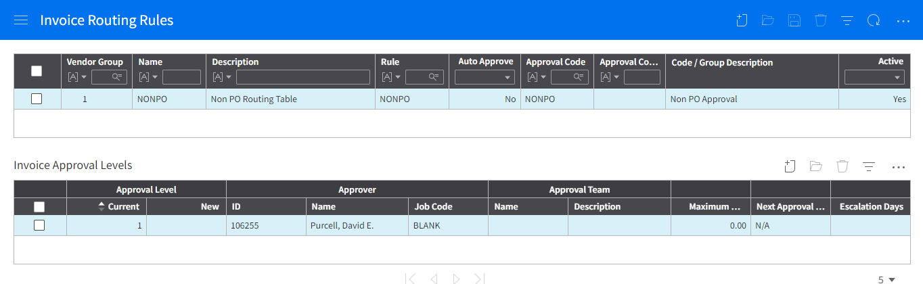

2.5.1.2 Custom Group

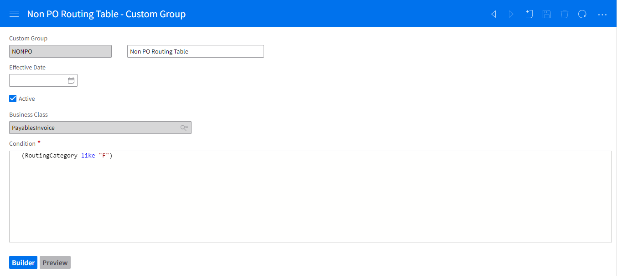

2.5.1.3 Invoice Approval Codes

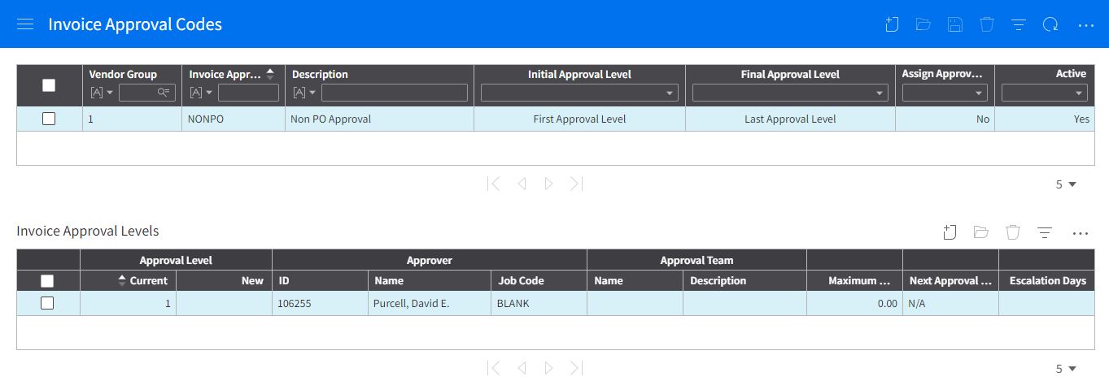
The Invoice Approval Code will only be used in the Reassignment process for when users need to reassign an invoice.
The Invoice Approval Levels will contain all employees who are allowed to be set as a reassignee, those with Supervisor Type of SUP, MGR and DIR. Baycare will maintain the addition, updating and deletion of employees in the Invoice Approval Levels.

2.5.1.4 Invoice Routing Category

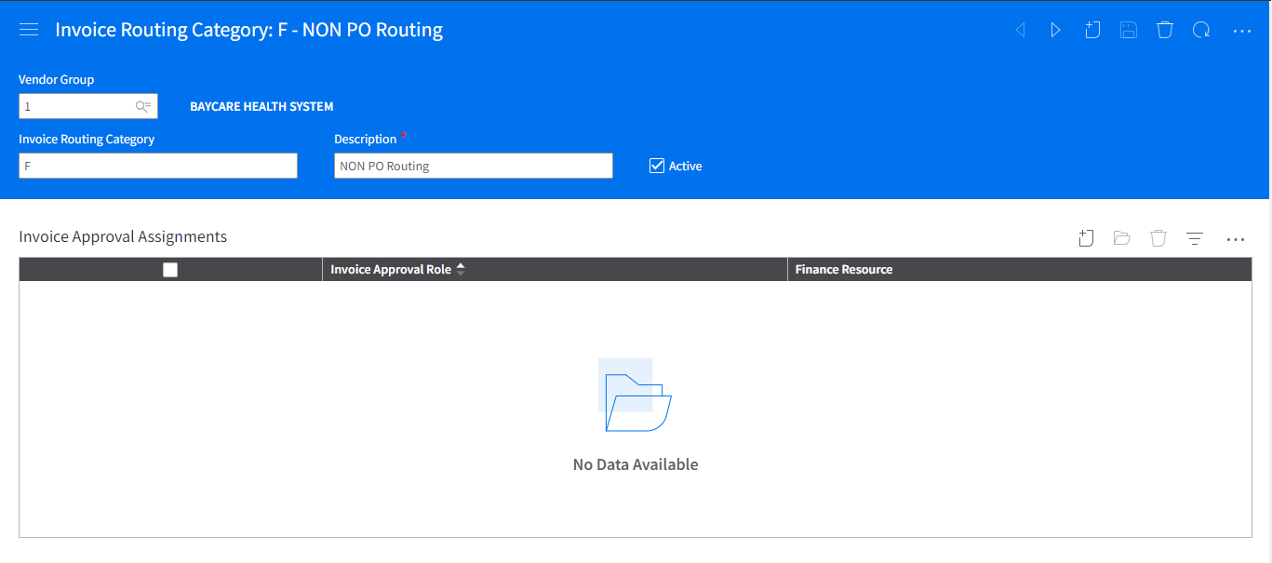

2.5.1.5 Action Reasons

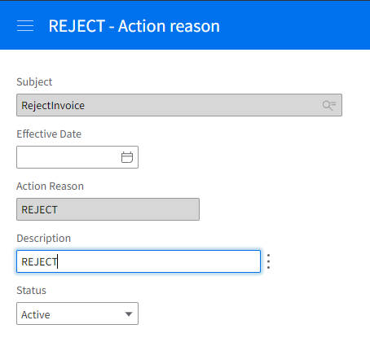

For auto-reject scenarios, the ‘REJECT’ action reason will be defaulted in the Reason field and ‘Auto-reject’ will be defaulted in the Action Comments field.

2.5.1.6 Proxy

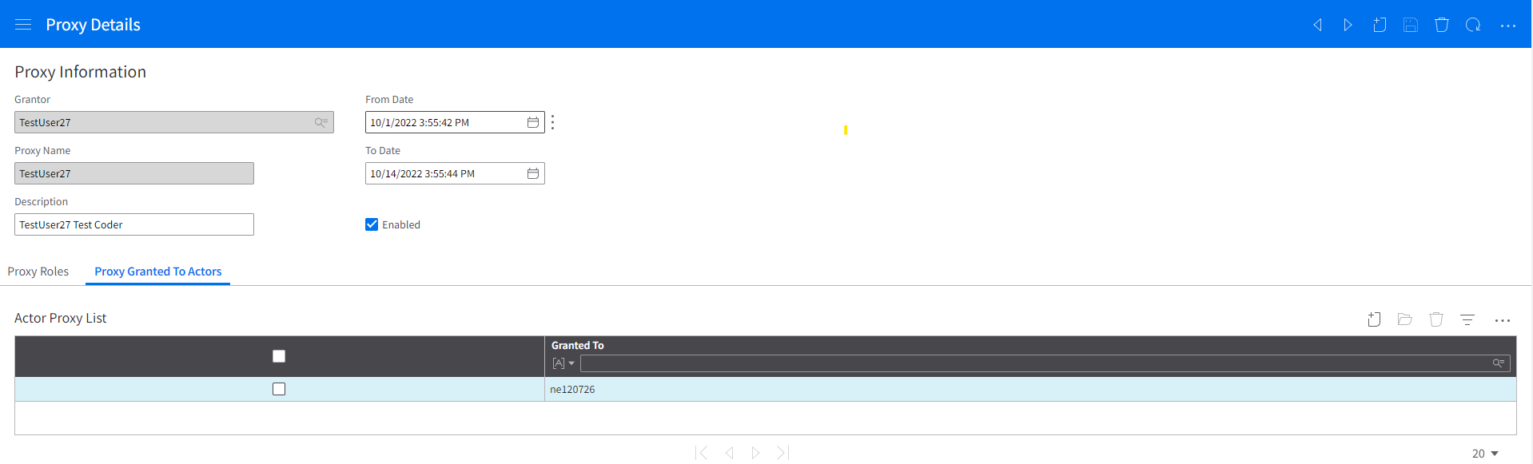
Proxy will be used to identify whom the invoice will be routed to for approval based on the defined date ranges and enabled checkbox.
If proxy is set up, the invoice will not be routed to the original approver nor will they receive and email for the invoice requiring approval.
No multiple grantees will be identified in the Proxy Granted to Actors tab.

2.5.1.7 Calendar

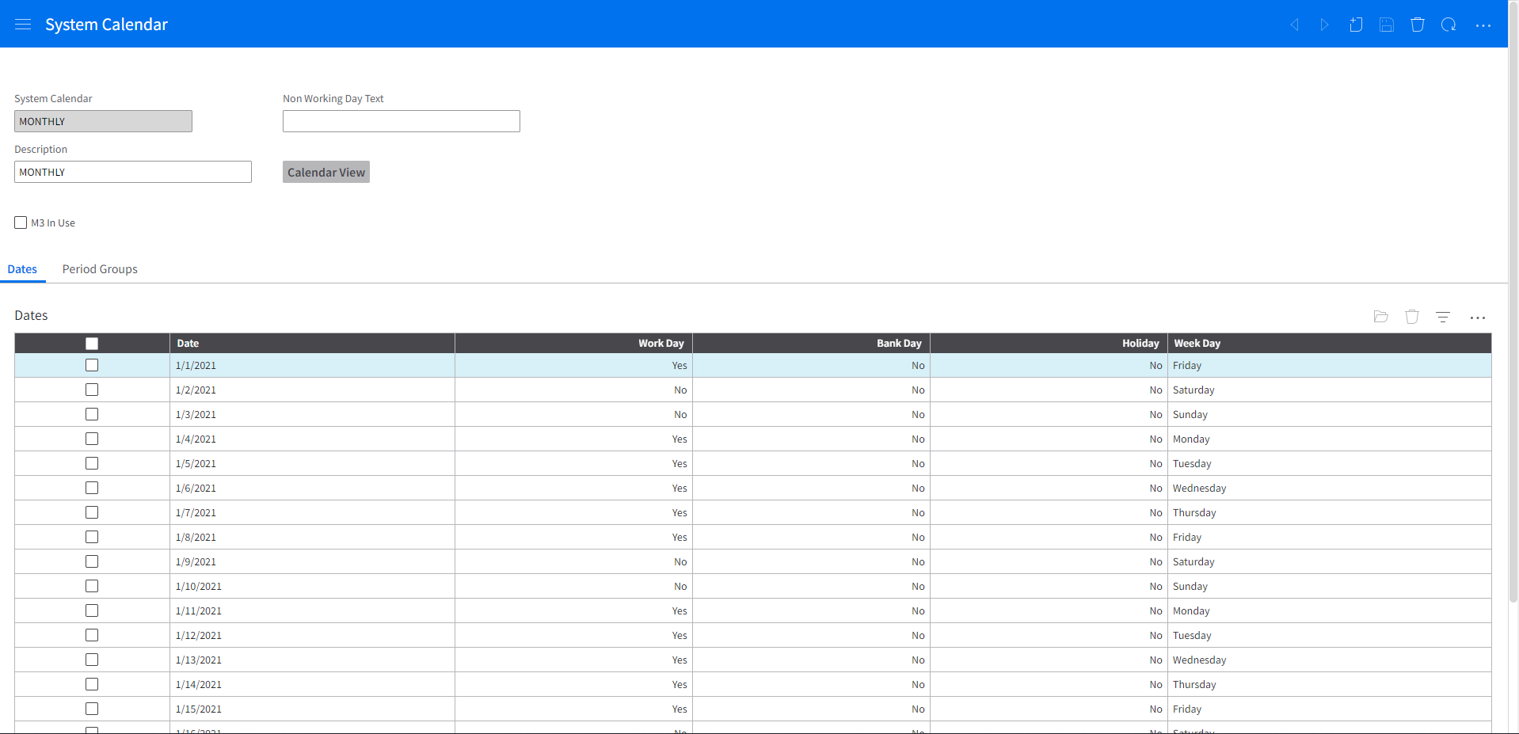
The System Calendar will be used to identify the number of business days for escalation and email reminders.

2.5.2 GHR Setup

2.5.2.1 HR Organization Unit

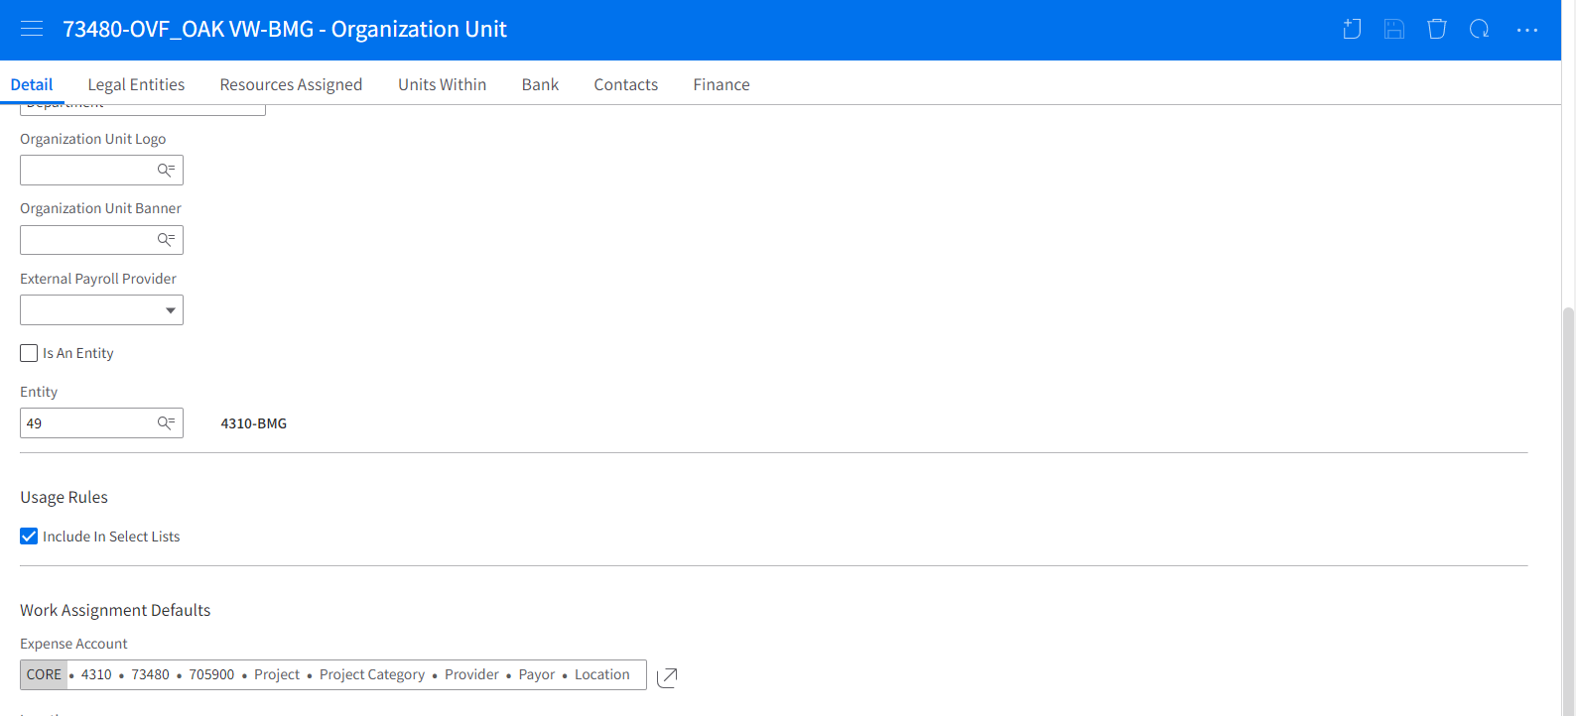
The Work Assignment Defaults – Expense Accounts Company and Department field values is used as the basis for identifying the HR Organization Unit to be used in routing the AP Invoice. The Expense Accounts Company and Department field is cross reference against the Payables Invoice To Accounting Entity and Finance Dimension 1 values.

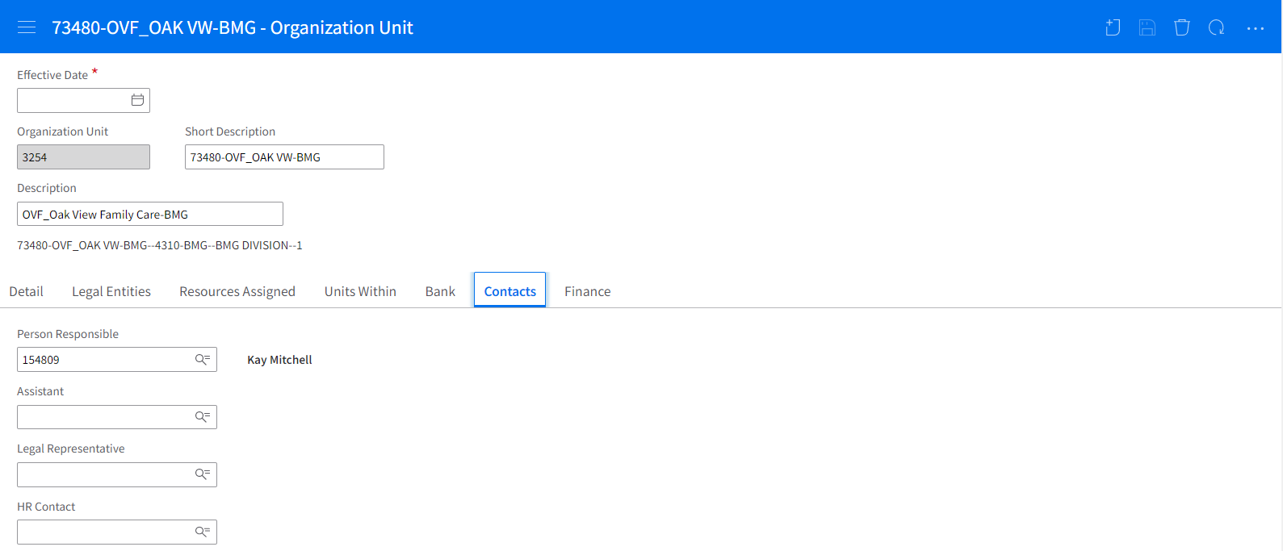
The Person Responsible indicated in the HR Organization Unit is the entry point of invoice approval in the HR organization hierarchy.

2.5.2.2 Work Assignment

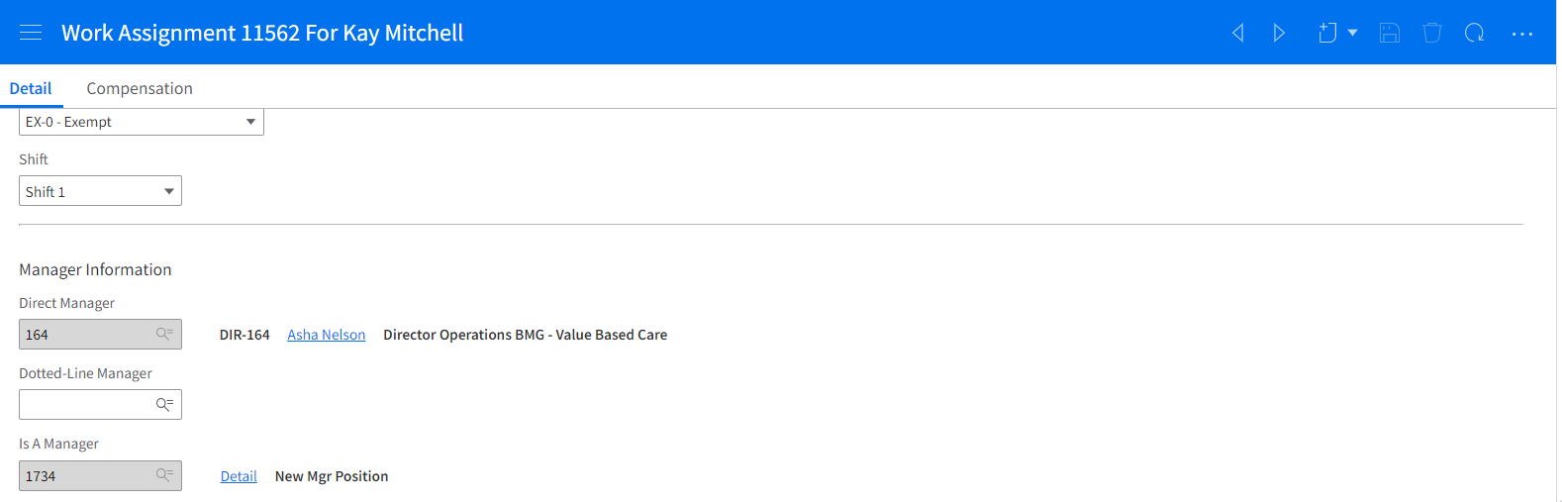
The Direct Manager field is used to identify the next level of approval if invoice amount is greater than the authority amount of the current approver.
The Is A Manager field is used to identify if the employee has an approval authority.
In cases of multiple Work Assignments for an employee, the Primary Work Assignment (WorkAssignment.Primary = TRUE) will used to identify the Direct Supervisor and Manager Type for authorization limit identification.

2.5.2.3 Supervisor

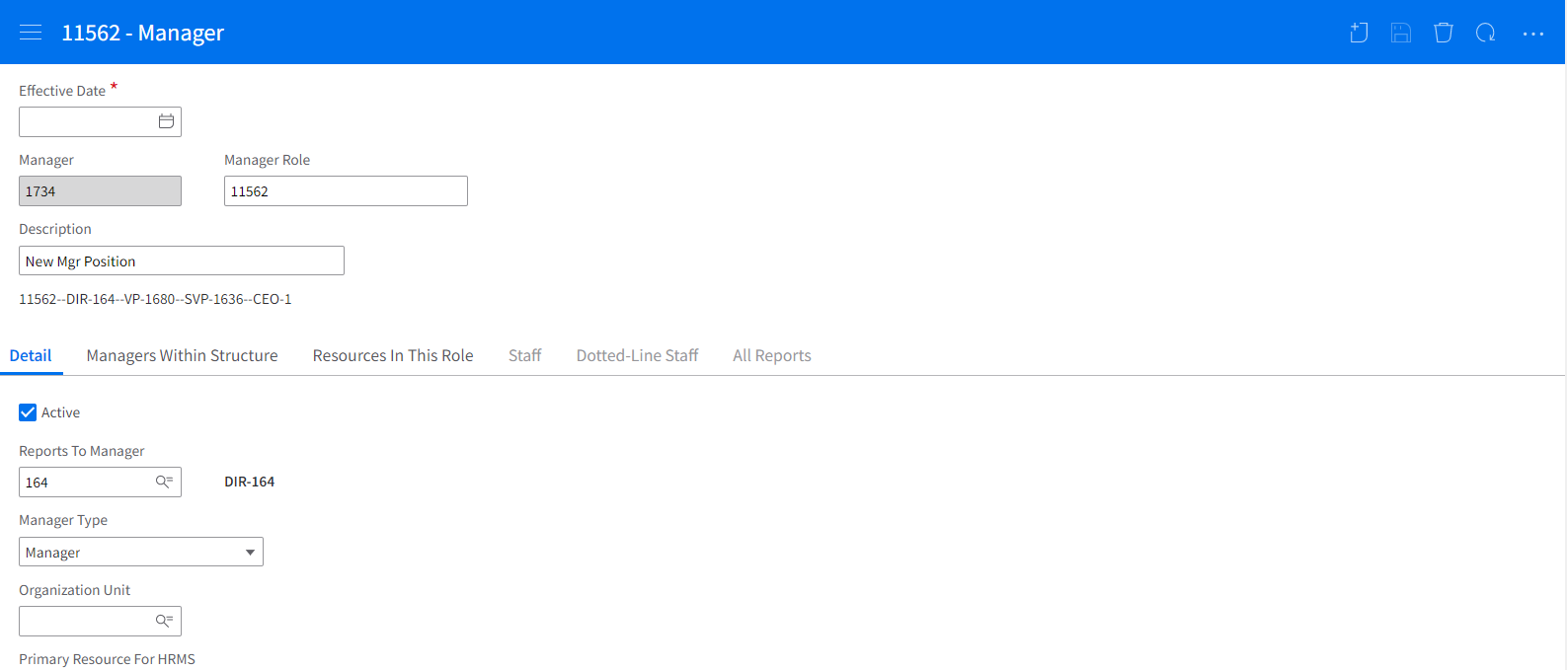
The Manager Type in the Supervisor setup is used to identify the authority limit of the employee.

2.5.2.4 Relationship to Organization

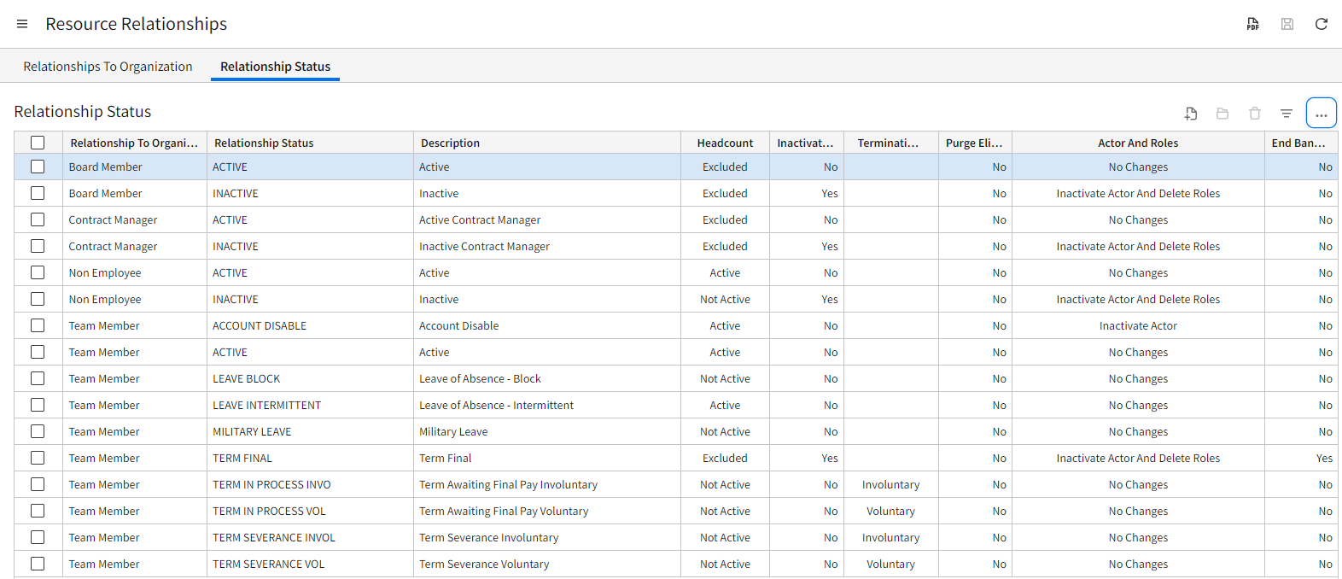

The relationship status of Active or Leave Intermittent for Team Member and Contract Manager will be used in determining the appropriate approval routing.

Cross Reference Tables
At times, there a 1 to 1 relationship does not exist between required fields (Infor and vendor), resulting in the use of a cross reference table. In these situations, outline the cross-reference table requirements, field names, and logic for when to use this information. This will be created in the Process Sever Administrator > Configuration > Cross Reference table (by CSF or HCM applications).

Cross Reference
Source Business Class | XRef Name | Based on | Lookup Field | Comments
PfiXRefCode | CODER - cross reference – custom | [Company Department] from Invoice | Employee | Coder lookup table by Company Department

PfiXRefCode - Custom Coder Table - CODER
Field | Description | Field Length | Field Type | Comments
Company | Company | 4 | Numeric | Company Number
Company Name | Company Name
Department | Department number | 5 | Numeric | Department Number
Department Name | Department Name
Employee | Employee ID Number |  | Numeric | Employee ID Number

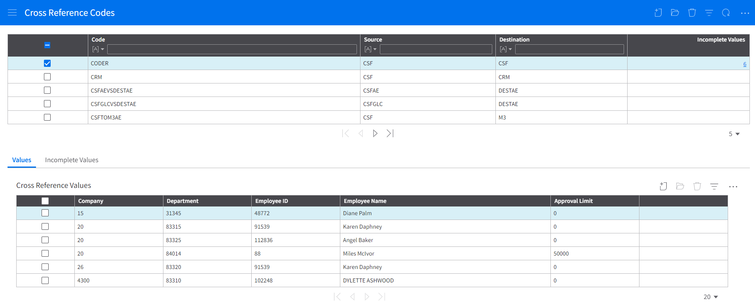

HROrganizationUnit:
Field | Description | Field Length | Field Type | Comments
HROrganizationUnit | HR Org Unit |  | Numeric
Person Responsible | Employee ID | 13 | Numeric | This will be the employee to lookup on the supervisor business class
GLCompany | Company | 4 | Numeric | HROrganizationUnit.ToAccountingEntity (ParentLink: ExpenseAccount.ToAccountingEntity) = PayablesInvoiceDistribution.ToAccountingEntity
Department | Department | 5 | Numeric | HROrganizationUnit.FinanceDimension1 = PayablesInvoiceDistribution.FinanceDimension1
UnitType | DEPARTMENT |  | Alpha | UnitType = DEPARTMENT only

Supervisor:
Field | Description | Field Length | Field Type | Comments
HROrganizationUnit |  |  | Numeric
Supervisor
SupervisorType | Description of the role, based on supervisor value |  |  | Identify what level to lookup on the approval table XREF

APIA_NONPOROUTING_Approval_Matrix
Cost Center Approver thresholds for Non-PO Invoices, P-card, Check Requests, and Service PO’s:
Position | Invoice Amount | Comments
Supervisor | <1,000.00 | If Invoice amount is less than the amount, stop approval at this level, if not, continue to the next level
Manager | <50,000.00 | If Invoice amount is less than the amount, stop approval at this level, if not, continue to the next level
Director | <150,000.00 | If Invoice amount is less than the amount, stop approval at this level, if not, continue to the next level
Vice President | <750,000.00 | If Invoice amount is less than the amount, stop approval at this level, if not, continue to the next level
Sr. Vice President | <750,000.00 | If Invoice amount is less than the amount, stop approval at this level, if not, continue to the next level
Executive Vice President | <750,000.00 | If Invoice amount is less than the amount, stop approval at this level,  When no action is done at this level, auto reject.

Technical Details
Describe the corresponding technical details related to the program, including the name, run schedule and job where applicable, process trigger, data source, and development tool.
Name | Tool | Process Definition | Data Set(s) | Frequency | Repository | Job Name | Job Stream | Comments
APIA_NONPOROUTING | IPA | InvoiceApproval_APIA_NONPOROUTING |  | Trigger

Service Definition:
Service | InvoiceApproval
Service Is Enabled | True
Criteria 1 | Company
Criteria 2 | ProcessLevel
Criteria 3
Proces Definition | APIA_NONPOROUTING
Service Process Is Enabled | Yes

Screenshot of User Defined Process:
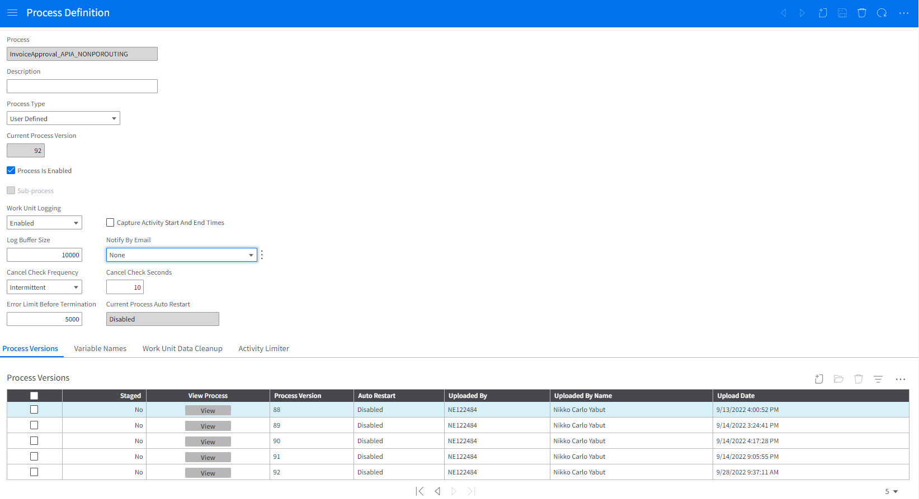

Screenshot of Service Definition:
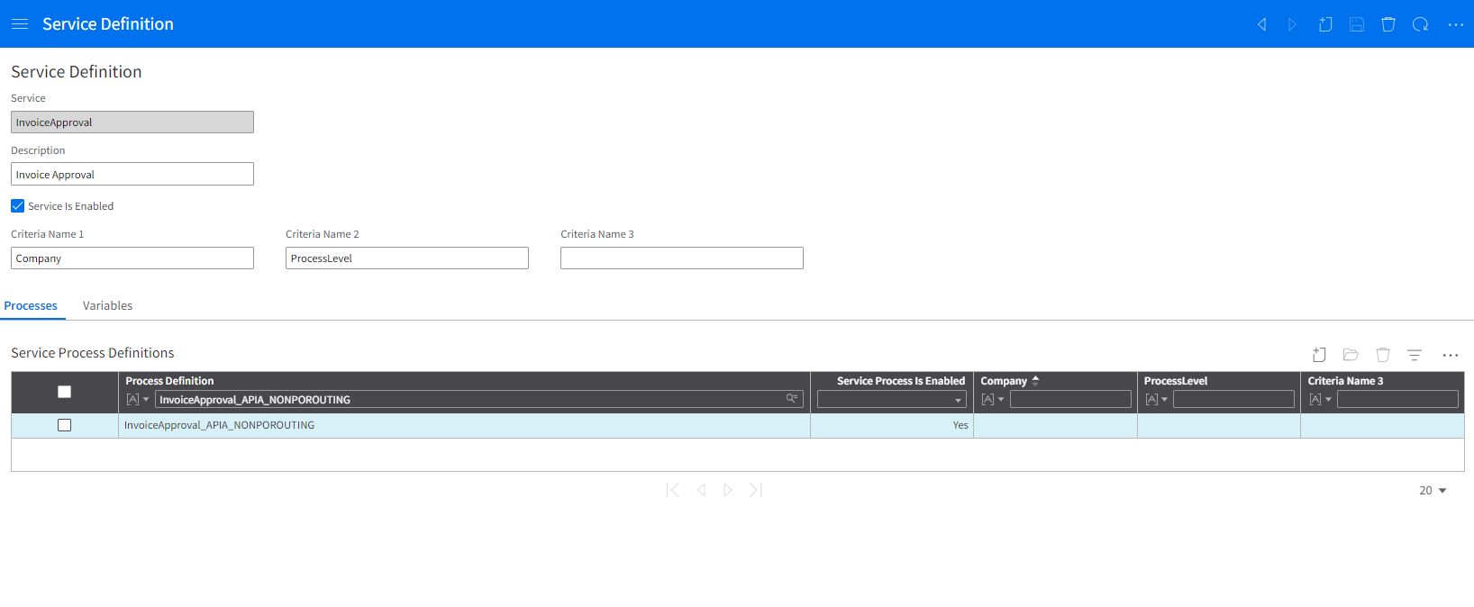

System Configuration:
Navigation: Process Server Administrator > Configuration > System Configuration > Interface
Property Name | Value | Description
APIA_NONPOROUTING_Approval_Category | INCLUSIVE | INCLUSIVE: Approval range is [0,Limit];  EXCLUSIVE: Approval range is [0,Limit)
APIA_NONPOROUTING_Approval_Matrix | SUPV,1000,MGR,50000,DIR,150000,VP,750000,SVP,750000,EVP,750000, | format: SupervisorType1, ApprovalAmountLimit1, SupervisorType2, ApprovalAmountLimit2,...
APIA_NONPOROUTING_AutoReject_Recipient | <email address of recipient/s of autoreject emails> | Email address of auto-reject notification
APIA_NONPOROUTING_Test_Flag | TRUE/FALSE | Set to "TRUE" if APIA_NONPOROUTING is under testing; Set to "FALSE" if otherwise
APIA_NONPOROUTING_Test_Actor | <Actor of test actor> | If APIA_NONPOROTUING_Test_Flag==TRUE, UserAction and emails will be routed to this actor
APIA_NONPOROUTING_InsertApprover | 154210;57072; | format: val1;val2 -- if next approver is val1, it will be routed to val2 and its hierarchy
APIA_NONPOROUTING_ManualReject_Recipient |  | Recipient of Manual Reject Email Notification
APIA_NONPOROUTING_RelationshipStatus | ACTIVE,LEAVE INTERMITTENT
APIA_NONPOROUTING_RelationshipToOrganization | TEAM MEMBER,CONTRACT MANAGER

System Configuration:
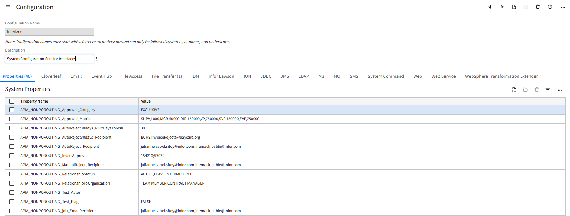

Technical Data Source
PayablesInvoice:
Field | Field Length | Field Type | Comments
Company | 4 | NUMERIC
Invoice | 22 | ALPHAUPPER
DerivedAPClerkName | 250 | ALPHALOWER
DerivedVendorName | 120 | ALPHALOWER
DerivedFormattedInvoiceDueDate | 10 | ALPHALOWER
DerivedFormattedInvoiceDate | 10 | ALPHALOWER
InvoiceAmount.CurrencyAmount | 19 | BCD
InvoiceCurrency | 5 | ALPHAUPPER
DerivedVendorNameID | 132 | ALPHALOWER
DerivedCompanyNameID | 2048000 | ALPHALOWER
InvoiceDate | 8 | YYYYMMDD

SystemCalendarDate:
Field | Field Length | Field Type | Comments
SystemCalendarDate | 8 | YYYYMMDD
IsWorkingDay |  | BOOLEAN | TRUE

PayablesInvoiceDistribution:
Field | Field Length | Field Type | Comments
Company | 4 | NUMERIC | <!Company>
PayablesInvoice | 18 | Numeric | <!PayablesInvoice>
PayablesInvoiceDistribution | 6 | NUMERIC
GLFinanceCodeBlock.ToAccountingEntity | 12 | ALPHAUPPER
GLFinanceCodeBlock.FinanceDimension1 | 15 | ALPHAUPPER
GLFinanceCodeBlock.GeneralLedgerChartAccount | 26 | ALPHAUPPER

PfiXRefValue:
Field | Field Length | Field Type | Comments
XRefCode.Code | 255 | ALPHALOWER | CODER
XRefCode.Source | 40 | ALPHALOWER | CSF
XRefCode.Destination | 40 | ALPHALOWER
SourceValue1 | 50 | ALPHALOWER
SourceValue2 | 50 | ALPHALOWER
SourceValue3 | 50 | ALPHALOWER
SourceValue4 | 50 | ALPHALOWER

Employee:
Field | Field Length | Field Type | Comments
HROrganization | 4 | ALPHAUPPER
Employee | 13 | NUMERIC | <!vCoderEmpID> for Coder  <!LMTxnXXXX_PersonResponsible> for Person Responsible
EmployeeName | 100 | ALPHALOWER
GivenNameWithNoPunctuation | 20 | ALPHALOWER
LastNameWithNoPunctuation | 20 | ALPHALOWER
EmployeeActor | 100 | ALPHALOWER

Proxy:
Field | Field Length | Field Type | Comments
Actor | 30 | ALPHALOWER | <!LMTxnXXXX_EmployeeActor>
IsEnabled |  | BOOLEAN | TRUE

ActorProxy:
Field | Field Length | Field Type | Comments
Actor | 30 | ALPHALOWER | <!LMTxnXXXX_EmployeeActor>
ActorProxy.Grantee | 30 | ALPHALOWER

Agent:
Field | Field Length | Field Type | Comments
KeyText | 100 | ALPHALOWER
ParentAgent.Actor | 30 | ALPHALOWER | <!LMTxnXXXX_ActorProxy_Grantee>

HROrganizationUnit:
Field | Field Length | Field Type | Comments
UnitType | 20 | ALPHAUPPER | DEPARTMENT
HROrganization | 4 | ALPHAUPPER
HROrganizationUnit | 6 | NUMERIC
PersonResponsible | 13 | NUMERIC | != 0
ExpenseAccount.ToAccountingEntity | 12 | ALPHAUPPER | <!vCoderCompany>
ExpenseAccount.FinanceDimension1 | 15 | ALPHAUPPER | <!vCoderDept>

WorkAssignment:
Field | Field Length | Field Type | Comments
HROrganization | 4 | ALPHAUPPER
WorkAssignment | 4 | NUMERIC
Employee | 13 | NUMERIC | <!vCurrApprEmpID>
AssignmentIsSupervisor | 9 | NUMERIC
DirectSupervisor | 9 | NUMERIC

Supervisor:
Field | Field Length | Field Type | Comments
HROrganization | 4 | ALPHAUPPER
Supervisor | 9 | NUMERIC | <!LMTxnXXXX_AssignmentIsSupervisor>
SupervisorType | 20 | ALPHAUPPER

Technical Diagram
Include a screenshot of the technical diagram from the Infor Process Designer, ION Workflow, Report Structure, or Process Automation design.

IPA Diagram:

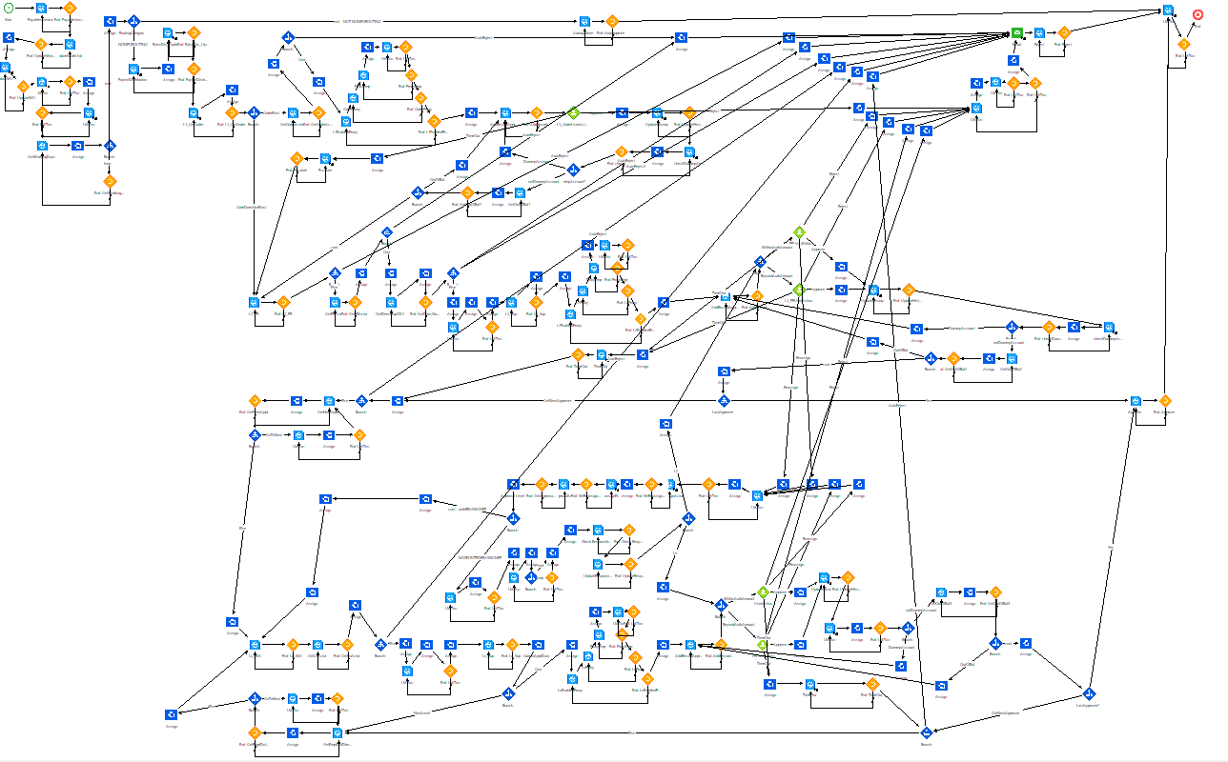
IPA for APIA autoreject after 30 days

Sample Pseudocode
Include the technical overview of the program from a logical perspective.
PortalPayablesInvoiceGeneralInformationViewOnly is a Form
title is "<DerivedFormTitle>"
Layout
display as text
three column distributed
column1
DerivedCompanyNameID
label is "Company"
paragraph
APClerk.PreferredSimplePresentationName
label is "Processor"
button of "<APClerk.Employee.EmployeeWorkEmailAddress>"
visible when (APClerk.Employee.EmployeeWorkEmailAddressExists)
link is "mailto:<APClerk.Employee.EmployeeWorkEmailAddress>"
display as link
button of "<APClerk.Employee.EmployeeWorkTelephone>"
visible when (APClerk.Employee.EmployeeWorkPhoneExists)
link is "tel:<APClerk.Employee.EmployeeWorkTelephone>"
display as link
visible when (DiscountAmountEntered)
DiscountDate
visible when (TaxInformationEntered)
TaxableAmount
label is "EnteredTaxableAmount"
PayablesInvoiceTaxRel.TotalInvoicedTaxableAmount
PayablesInvoiceTaxRel.TotalAccruedTaxableAmount
column2
VoucherNumberDisplay
DerivedRemitToNameID
visible when (DiscountAmountEntered)
DiscountAmount.CurrencyAmount
label is "DiscountAmount"
visible when (TaxInformationEntered)
TaxAmount
label is "EnteredTaxAmount"
PayablesInvoiceTaxRel.TotalInvoicedTaxAmount
PayablesInvoiceTaxRel.TotalAccruedTaxAmount
column3
visible when (PurchaseOrderEntered)
paragraph
DisplayPurchaseOrder
button of "ViewPO"
visible when (DisplayPOLink)
link is FirstPOInformation
display as link
visible when (ServiceContractEntered)
ServiceContract
visible when (AllowUpdateOnApprove)
header2 of "ApproverInformation"
display as text
visible when (first PfiWorkunitRel.HasProcessIndicator)
single column
first PfiWorkunitRel.PfiProcessIndicatorRel.Model
no label
paragraph
last PayablesInvoiceAudit set.Status
display as tag
color of blue when (last PayablesInvoiceAudit set.Status.Assigned)
color of blue when (last PayablesInvoiceAudit set.Status.Reassigned)
color of red when (last PayablesInvoiceAudit set.Status.Rejected)
color of green when (last PayablesInvoiceAudit set.Status.Approved)
color of red when (last PayablesInvoiceAudit set.Status.Disapproved)
color of green when (last PayablesInvoiceAudit set.Status.AutoApproved)
color of blue when (last PayablesInvoiceAudit set.Status.PendingApprover)
color of blue when (last PayablesInvoiceAudit set.Status.Restored)
color of blue when (last PayablesInvoiceAudit set.Status.MatchReleased)
color of blue when (last PayablesInvoiceAudit set.Status.SentForPayment)
color of blue when (last PayablesInvoiceAudit set.Status.Submitted)
color of red when (last PayablesInvoiceAudit set.Status.Cancelled)
color of green when (last PayablesInvoiceAudit set.Status.ManuallyApproved)
color of red when (last PayablesInvoiceAudit set.Status.ManuallyRejected)
color of green when (last PayablesInvoiceAudit set.Status.Released)
color of blue when (last PayablesInvoiceAudit set.Status.Matched)
color of blue when (last PayablesInvoiceAudit set.Status.Unmatched)
color of blue when (last PayablesInvoiceAudit set.Status.Amended)
visible when (last PayablesInvoiceAudit set.ActionReason entered)
last PayablesInvoiceAudit set.ActionReason
label is "Reason"
visible when (last PayablesInvoiceAudit set.Comment entered)
last PayablesInvoiceAudit set.Comment
show up to 30 characters
visible when (not first PfiWorkunitRel.HasProcessIndicator)
two column
DerivedPreviousRoutingApprover
two column distributed
column1
header2 of "ReassignInformation"
paragraph
visible when (ReassignToPreviousApproverValid)
ReassignToPreviousApprover
DerivedPreviousRoutingApprover
no label
display as text
visible when (ReassignToPreviousApproverValid)
text of "-\\Or_-"
paragraph
ReassignToApprovalLevel
label is "ReassignTo"
select is InvoiceApproversPFlowSelect
ReassignToApprovalLevel.ApprovalLevel
display as text
ReassignToApprovalLevel.DerivedDescription
no label
display as text
text of "ApprovalLevelRequiredIfReassigningTheInvoiceToAnotherLevel"
bold
italics
color of red
column2
visible when (RoutingCode.UsesTeamMemberAssignment)
header2 of "RoutingInformation"
paragraph
RoutingFinanceTeam
RoutingFinanceTeamMember.TeamMember
label is "RoutingTeamMember"
select is ActiveRoutingResourceSelect
RoutingFinanceTeamMember.TeamMember.PreferredSimplePresentationName
no label
display as text
text of "Routing_\\Team_\\MemberIndicatesAssignedApproverWhenThe_\\Finance_\\TeamMatchesApprovalLevelTeam"
bold
paragraph
text of "ReassignToNewTeamByUpdatingRoutingTeam,MemberAndApprovalLevel"
bold
italics
color of red
paragraph
text of "ReassignToNewTeamMemberByUpdatingRoutingTeamMember"
bold
italics
color of red

Technical Deployment Notes
Document change control and go live considerations to ensure the program is successful. What are the requirements to promote to production; custom program, data set (i.e. replication set), process trigger, job console set up, scheduling considerations, FTP directory, credentials, and troubleshooting steps.
- Set APIA_NONPOROUTING_Test_Flag=FALSE
- Set APIA_NONPOROUTING_AutoReject_Recipient to recipients of auto-reject email notifications

Quality assurance
With any technical development, maintaining testing standards and review processes are paramount for ensuring the expected outcomes are achieved. This document outlines the quality assurance steps required for the approval process.

Test Plan
Outline the test plan for development, unit, and end user validation testing.
Phase | Scenarios | Results | Resolution | Target Date(s) | Testers | Comments
Development
Unit
System Integration Testing (SIT) | Test multiple department hierarchies
System Integration Testing (SIT) | Test both coder and without coder
User Acceptance | Test approval, rejection, and reassignment
Production

Testing Considerations
Consider end user scenarios, timing of when the testing is completed, the environment, size of the data/file, and the target audience.
This IPA is testing during various phases of the implementation process. The following test criteria should be considered:
- Approvers receive notifications of an invoice awaiting their approval.
- Invoices with specified Departments are routed to the appropriate processor for review and coding.
- Invoices designated with UTL (utilities) Vendor Class are auto approved.
- Invoices submitted for approval route to the appropriate approver based on the role and dollar amount threshold.
- Invoices not approved within the established timeframe are escalated to the next level for approval.

Functional Testing Documentation
Ensure the supporting testing information is included with this document and stored in the same folder. Include the directory/filepath information below.

End User Training
If this custom program results in multiple users interacting with the output, document the end user training considerations and plan.

Terminology
Define and key terms or language that provides a more robust understanding of this program.
Coder – Identified user who reviews and updates the Payables Invoice Distribution to appropriate values, regardless of dollar amount.

